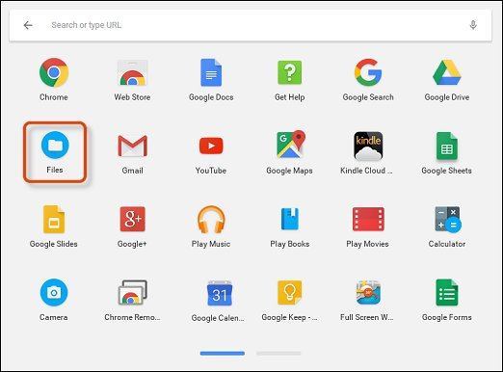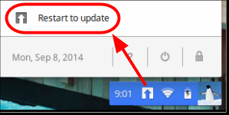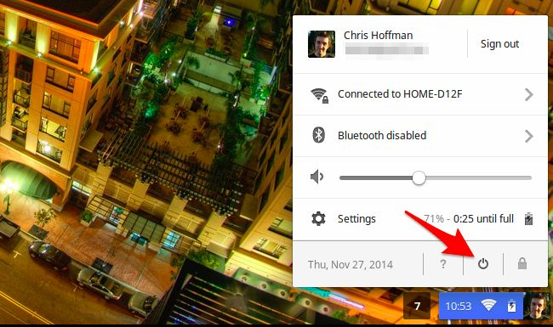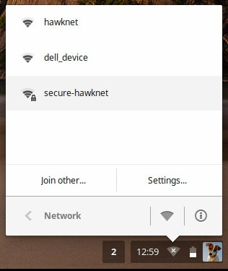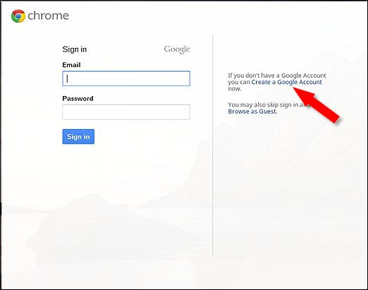 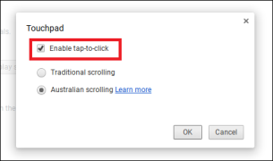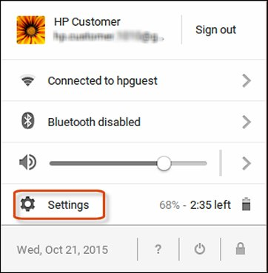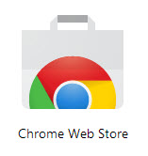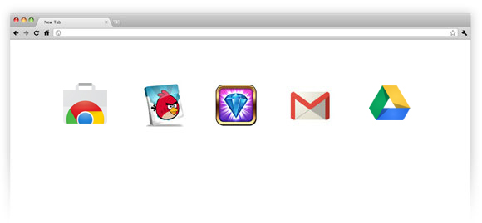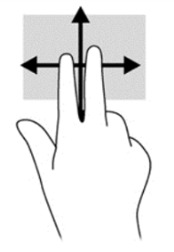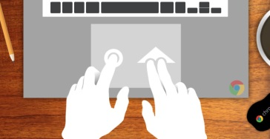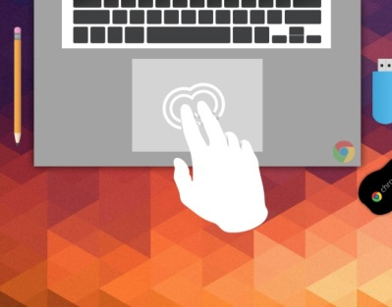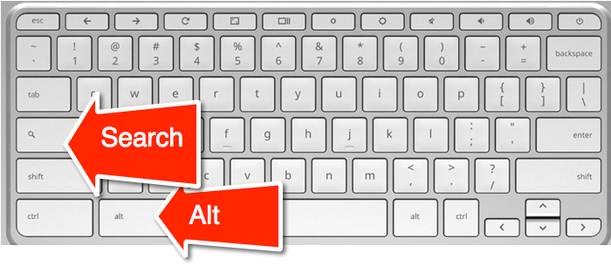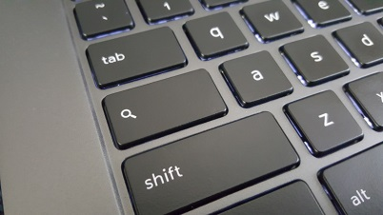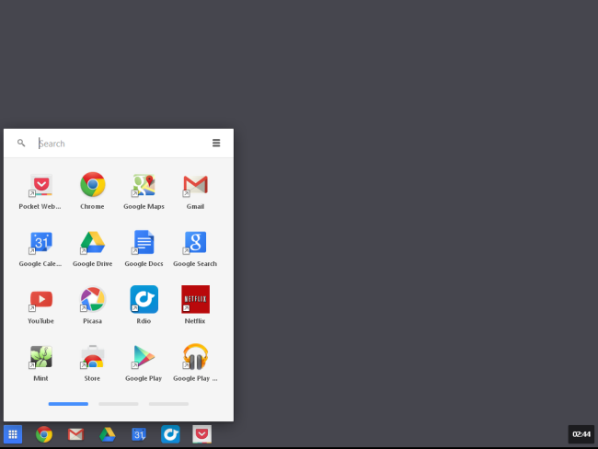

You must have a Google account to login. If you do not have a Google account you can create one from this location also. By having a Gmail (or Google account) you are now ready to explore. Your Chromebook will automatically search for Wi-Fi networks around you. To connect to Wi-Fi you may be prompted to enter a password, some locations require this, as well as your home. Once the Wi-Fi connects, Your Chromebook will then search for updates. Proceed with any updates, once completed you will be prompted to login to your Google Account. Once connected you are ready to explore.

To Power ON a Chromebook you simply open the Chromebook and it turns on. If this fails to work you can press the power button. To Power off the Chromebook you can press the power button or press in the right corner where your information is located and press the shutdown feature. If you see the up arrow symbol this means updates are available. Press this button to receive your updates.

You can access the files app from your search feature. By pressing search or the bottom left corner the files folder contains your documents, spreadsheets, etc. You also have access to Google Drive which is internet storage of your documents, photos, etc.

Peabody Public Library

1160 E State Road 205

Columbia City, IN 46725

www.ppl.lib.in. us

260-244-5541

Quick Reference Guide

Chromebooks

Free One on One Appointments available call Beth

**Google Drive**

**Accessing Files**

***Google Drive and Files***

**Update Symbol**

**Powering On and Off**

***Powering On and Off / Updates***

***Quick Reference Sheet***

**Getting connected to Wi-Fi**

**Logging in and creating an account**

***Wi-Fi & Logging into Your Account***

In The bottom left corner of the screen is a search option. This will allow you to choose Google apps and search the internet. You can also place apps in the task bar to have instant access. You may notice your CAPS Lock button has been replaced with a search button. When you press this button it brings up the same window located in the left corner. This is your search options. You can press shift to capitalize letters or turn on/off CAPS by pressing ALT + the search button located on your keyboard. You can retrieve Google apps from this area also. You can also use the OK Google feature which is voice typing.

**Change your Settings and use the ? to ask a question.**

Quick Reference Guide

Chromebooks

Free One on One Appointments available call Beth

***Quick Reference Sheet***

To locate and get apps you must access the Chrome Store. You access this the same way you do all of the other apps. Press on the Chrome Webstore and look for other apps.

***Searching the Chrome Webstore***

**Locking in CAPS**

Touch Pad Tips

1. To move the pointer simply move your fingers across the touchpad in a left or right direction
2. To click press down on the lower half of the touchpad.
3. To right click, click the touchpad with two fingers (like shown in picture)
4. To scroll Place two fingers on the touchpad and move them up and down to scroll vertically, and left to right for horizontal
5. You can also purchase a wired or wireless mouse to use instead on the touch pad.

***The Touchpad***

**Search button**

**on Keyboard**

**Search and get other Google Apps**

***The Desktop and Searching***

Peabody Public Library

1160 E State Road 205

Columbia City, IN 46725

www.ppl.lib.in. us

260-244-5541